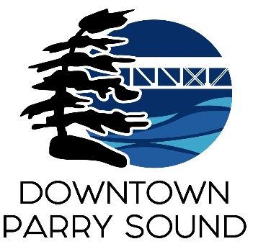Agenda

Parry Sound Downtown Business Association

Board of Directors Meeting

September 10, 2025, 6:30pm – Parry Sound Public Library

ITEM

1. Welcome & Call to Order Meredith

2. Additions; prioritization & approval of this agenda Meredith

3. Approval of the minutes for August 13, 2025 Meredith

4. Conflict of interest declaration. Meredith

5. Correspondence: April



6. Old Business: April

* Action Plan: approve Hiring policy.

7. New Business:

* Explorers’ Edge 2026 Partnership funding

8. Reports:

* Financial Report Kaila
* Beautification Committee Bernice
* Events Committee April
* Marketing Committee April
* Council Representative Chris
* Staff Report April

Next meeting: October 8, 2025 – Parry Sound Public Library Adjournment