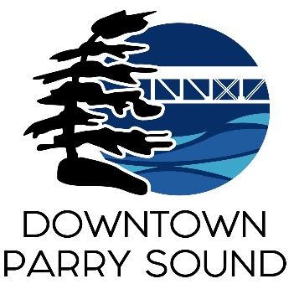Agenda

Parry Sound Downtown Business Association

Board of Directors Meeting

July 9, 2025, 6:30pm – Parry Sound Public Library

ITEM

1. Welcome & Call to Order Meredith

2. Additions; prioritization & approval of this agenda Meredith

3. Approval of the minutes for June 11, 2025 Meredith

4. Conflict of interest declaration. Meredith

5. Correspondence:

* Callin Belchamber, Manager – IT: Downtown Map April
* Mike Kearns: MOU items April/Chris
* Dave Thompson: Town Dock, boat parking

6. Old Business: April

* Action Plan: approve Lending & Popcorn machine policies

Propose: Busking, Craft & Food Vendor and Downtown Dollars next

7. New Business: April/Meredith

* Parking Review: Miller St. to the CN overpass on Bowes St.

8. Reports:

* Financial Report Kaila
* Beautification Committee Bernice
* Events Committee April
* Marketing Committee April
* Council Representative Chris
* Staff Report April

Next meeting: July 9, 2025 – Parry Sound Public Library Adjournment