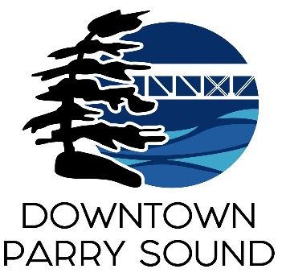Agenda

Parry Sound Downtown Business Association

Board of Directors Meeting

June 11, 2025, 6:30pm – Parry Sound Public Library

ITEM

1. Welcome & Call to Order Meredith

2. Additions; prioritization & approval of this agenda Meredith

3. Approval of the minutes – none (May was AGM) Meredith

4. Conflict of interest declaration. Meredith

5. Correspondence: April

* The Township of the Archipelago – Municipal Assistance grant

6. Old Business: April

* Blue Lagoon Patio – record motion & seconder
* Chamber of Commerce – Business Excellence Awards – criteria
* Action Plan: invalid/combined Policies & Procedures – prioritize updates

7. New Business: April

* Introduction of Sally O’Connor –Community Engagement/Deputy Clerk for the Town of Parry Sound
* DBA’s 50th Anniversary in 2027– Board Legacy Project

8. Reports:

* Financial Report Kaila
* Beautification Committee Bernice
* Events Committee April
* Marketing Committee April
* Council Representative Chris
* Staff Report April

Next meeting: July 9, 2025 – Parry Sound Public Library Adjournment