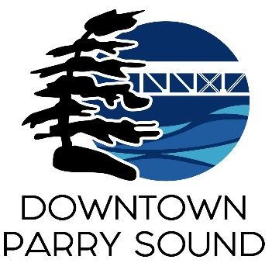Agenda

Parry Sound Downtown Business Association

Board of Directors Meeting

And 2025 AGM

May 14, 2025, 6:30pm – Parry Sound Public Library

ITEM

1. Welcome & Call to Order Meredith

2. Additions; prioritization & approval of this agenda Meredith

3. Approval of the minutes from March 12, 2025 Meredith

Approval of the minutes from May 8, 2024 Meredith

4. Conflict of interest declaration. Meredith

5. Correspondence: April

* Jeff Degagne: Director of Income Support & Stability

District of Parry Sound Social Services Administration Board – encampment

* Henny Groenendijk Baljet: Director of the Board

Festival of the Sound – Festival banners

6. Old Business: April

* Action Plan:

Outdated/invalid/combined Policies & Procedures recommendations

* Re-approve 2025 budget after Council changes

7. New Business:

* Social Media and Marketing year end wrap up Krista Holmes
* Chamber of Commerce presentation: Information kiosk at waterfront Chris McDonald
* Sidewalk patio applications: PS Wing House & 1000923800 Ont Inc. April
* Welcome Kjell Klockars

8. Reports:

* Financial Report Kaila
* Beautification Committee Bernice
* Events Committee April
* Marketing Committee April
* Council Representative Chris
* Staff Report – presentation April

Next meeting: June 11, 2025 – Parry Sound Public Library Adjournment