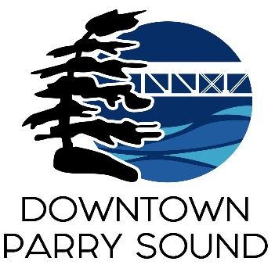Agenda

Parry Sound Downtown Business Association

April 9, 2025, 6:30pm – Parry Sound Public Library

ITEM

1. Welcome & Call to Order Meredith

2. Additions; prioritization & approval of this agenda Meredith

3. Approval of the minutes from March 12, 2024. Meredith

4. Conflict of interest declaration. Meredith

5. Correspondence: April

* Jeff Degagne: Director of Income Support & Stability

District of Parry Sound Social Services Administration Board

* Henny Groenendijk Baljet: Director of the Board

Festival of the Sound

6. Old Business: April

* Action Plan:

Outdated/invalid/combined Policies & Procedures recommendations

* Re-approve 2025 budget after Council changes

7. New Business:

* Chamber of Commerce presentation: Information kiosk at waterfront Chris McDonald
* Sidewalk patio applications: PS Wing House & 1000923800 Ont Inc. April

8. Reports:

* Financial Report Kaila
* Beautification Committee Bernice
* Events Committee April
* Marketing Committee April
* Council Representative Chris
* Staff – will prepare report for May meeting re: 2025 OBIAA Conference April

Next meeting: May 14, 2025 – Parry Sound Public Library Adjournment