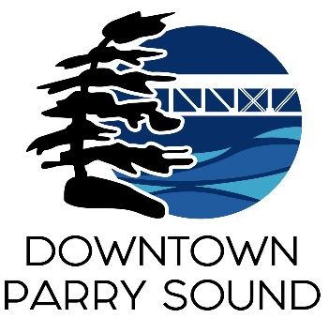Agenda

Parry Sound Downtown Business Association

February 12, 2025, 6:30pm – Parry Sound Public Library

ITEM

1. Welcome & Call to Order Meredith

2. Additions and or prioritization of this agenda Meredith

3. Approval of the minutes from December 11, 2024. Meredith

4. Conflict of interest declaration. Meredith

5. Presentation: Dave Thompson

Downtown Quality of Experience Team summary (cameras) and potential for advertising opportunities on the waterfront

6. Correspondence: April

* Frank Camenzuli – Official Plan (comments previously circulated)
* Deron Johnson - Orillia BIA – thank you

7. Old Business:

* Downtown Quality of Experience Team April
* Action Plan Meredith

8. New Business:

* Committee presentations April
* 2025 Budget Kaila

9. Reports:

* Council Representative Chris

Next meeting: March 12, 2025 – Parry Sound Public Library Adjournment