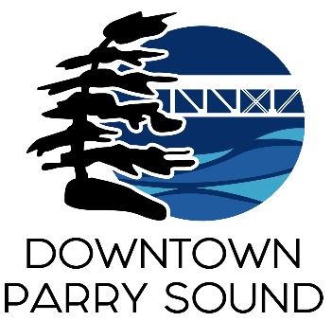Agenda

Parry Sound Downtown Business Association

March 12, 2025, 6:30pm – Parry Sound Public Library

ITEM

1. Welcome & Call to Order Meredith

2. Additions and or prioritization of this agenda Meredith

3. Approval of the minutes from February 12, 2024. Meredith

4. Conflict of interest declaration. Meredith

5. Correspondence: April

* [Great Lakes Waterfront Trail](https://waterfronttrail.org/the-trail/)
* Waterfront Master Plan Open House
* Jayme Young – Community Recreation Coordinator
* Township of McKellar

6. Old Business:

* Action Plan – Policies & Procedures + Code of Conduct Patty Hayes
* Follow up re: potential advertising opportunities on the waterfront Meredith

7. New Business:

* Sidewalk patio application – Oakcrest April

8. Reports:

* Financial Report Kaila
* Beautification Committee Bernice
* Events Committee April
* Marketing Committee April
* Council Representative Chris

Next meeting: April 9, 2025 – Parry Sound Public Library Adjournment