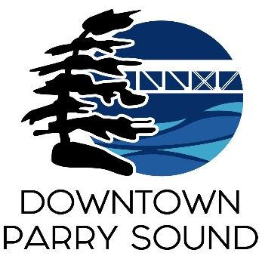Agenda

Parry Sound Downtown Business Association

November 13, 2024, 6:30pm – Parry Sound Public Library

ITEM

1. Welcome & Call to Order. Doug

2. Additions, prioritization and approval of agenda for tonight’s meeting. Doug

3. Approval of the minutes from October 09, 2024 Doug

4. Conflict of interest declaration. Doug

5. Correspondence: April

* Ryan McKeown – marketing for Girlfriends Weekend
* Councillor Ashford – fall boxes at intersection
* Amy Black – undesirable activity around Pardon My Garden
* Steve Anderson – state of maintenance at town dock.
* Chamber of Commerce – DBA sponsored award at Business Excellence event
* Parry Sound Living magazine ad comments

6. Old Business:

* Action Plan April
* Downtown Quality of Experience Team Chris

7. New Business: April

* DBA representation updates

8. Reports:

* Financials Kaila
* Beautification Bernice
* Events April
* Marketing Meredith
* Council Representative Chris
* Executive Director April

Next meeting: December 11, 2024 – Parry Sound Public Library Adjournment