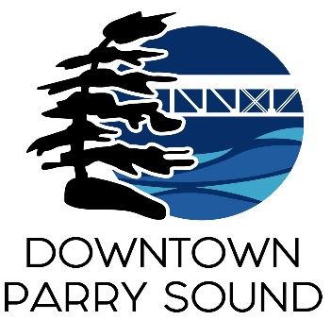Agenda

Parry Sound Downtown Business Association

December 11, 2024, 6:00pm – Parry Sound Public Library

ITEM

1. Welcome & Call to order April

* Introduction of Patty Hayes
* Elections – Chair & Vice Chair Patty
* Designate new signing official(s) New Chair

2. Additions and or prioritization of this agenda Chair

3. Approval of the minutes from November 13, 2024 Chair

4. Conflict of interest declaration. Chair

5. Correspondence: April

* Amy Black

6. Old Business: April

* Downtown Quality of Experience Team

7. New Business: Chair

* Resignation of Doug Wilton November 14, 2024
* Resignation of Tim Dunn November 18, 2024

8. DBA members invited for input on proposed events for 2025

Next meeting: January 8, 2024 – Parry Sound Public Library Adjournment