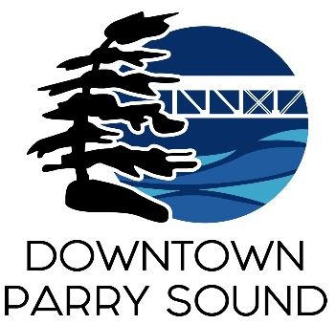Agenda

Parry Sound Downtown Business Association

September 4, 2024, 6:30pm – Parry Sound Public Library

ITEM

1. Welcome & Call to Order. Doug

2. Additions, prioritization and approval of agenda for tonight’s meeting. Doug

3. Approval of the minutes from September 4, 2024 Doug

4. Conflict of interest declaration. Doug

5. Correspondence: April

* Nicolas Youmbi – Councillor at École Publique aux Quatre-Vents
* Peter Istvan – Founders Circle
* Doris Muckenheim – Wolf Den

6. Old Business:

* Action Plan April
* Downtown Quality of Experience Team Chris

7. New Business: April

* Board representative on Events & Marketing Committees
* NOFHC Board Reception Invitation
* Northern BIA & Downtown Summit Invitation
* Available programs through NOHFC
* 2025 Budget Kaila

8. Reports:

* Financials Kaila
* Beautification Bernice
* Events April
* Marketing April
* Council Representative Chris
* Executive Director April

Next Meeting: November 13, 2024 – Parry Sound Public Library Adjournment