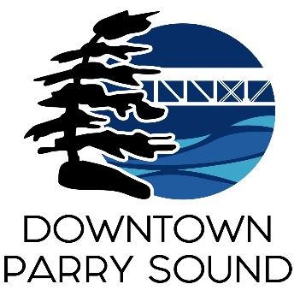Agenda

Parry Sound Downtown Business Association

September 4, 2024, 6:30pm – Parry Sound Public Library

ITEM

1. Welcome & Call to Order. Doug

2. Additions and approval of agenda for tonight’s meeting. Doug

3. Approval of the minutes from August 14, 2024 Doug

4. Conflict of interest declaration. Doug

5. Correspondence: April

* Citizen drop in – state of downtown
* MPP’s office – employment standard issue

6. Old Business: April

* Action Plan
* Downtown Quality of Experience Team

7. New Business: April

* Parking Proposal presentation – Frank Camenzuli & Sean Solowski

8. Reports:

* Financials Kaila
* Beautification Bernice
* Events April
* Marketing April
* Council Representative Chris
* Executive Director April

Next Meeting: October 9, 2024 – Parry Sound Public Library Adjournment