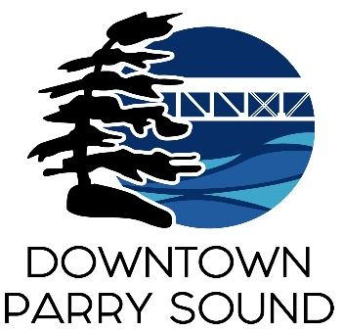
Agenda
Parry Sound Downtown Business Association
July 10, 2024, 6:30pm – Parry Sound Public Library

ITEM
1. Welcome & Call to order. Doug
2. Additions and approval of agenda for tonight’s meeting. Doug
3. Approval of the minutes from June 12, 2024 Doug
4. Conflict of interest declaration. Doug
5. Correspondence: April
- Parry Sound Public Library – asks DBA to consider writing a letter or email to the Parry Sound Public Library Board regarding accessibility to the library’s auditorium.
6. Old Business: April
- Letter to Mayor and Council update
7. New Business: April
- Downtown Quality of Experience Team
- Volunteer Parry Sound website
- Request to change September Board meeting date to September 4, 2024
8. Reports:
- Financials Kaila
- Beautification Bernice
- Events April
- Marketing April
- Council Representative Chris
- Executive Director April

Next Meeting: August 14, 2024 – Parry Sound Public Library

