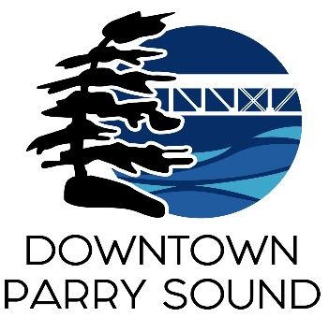
Agenda
Parry Sound Downtown Business Association
Board of Directors Meeting

March 8th^{th}, 2023 at 6pm – Parry Sound Public Library
ITEM
1. Call to Order Doug
2. Additions and approval of agenda for tonight’s meeting Doug
3. Approval of minutes from February 8th & 22nd, 2023 Doug
4. Conflict of interest declaration Doug
5. Correspondence April
- Amy Black – resigns from Events Committee.
- Frank Camenzuli – development charges concern.
- Liam Heffernan request to join the Board update.
6. Old Business April
- Scotia Bank – change of signers.

7. New Business April
- Policy & Procedure and Code of Conduct policies update.
- Patty Hayes action plan proposal.
- Cigarette smoking downtown.

8. Reports:
- Financials Meredith
- Beautification Bernice
- Events Mary-Ellen
- Marketing Seanan
- Council Chris
- Executive Director April

Next Meeting: April 12th, 2023 - 6pm - Parry Sound Public Library Adjournment

