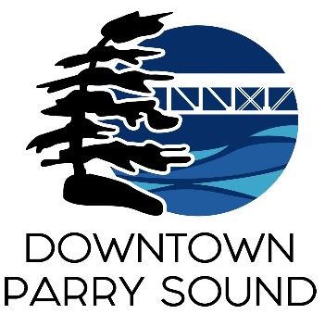
Agenda
Parry Sound Downtown Business Association
Board of Directors Meeting
January 11th, 2023 - 6:30pm - Parry Sound Public Library

ITEM
1. Call to Order
2. Additions and approval of agenda for tonight’s meeting
3. Approval of minutes from last meeting
4. Conflict of interest declaration
5. Correspondence
- BDO – 2023 audit
6. Old Business
- None
7. New Business
- PSDBA Board of Directors Seat nominations
- Update signers on bank account
- Committee Representatives
- Don Corbett’s request to join the Board
- Budget meeting date
8. Reports:
- Financials
- Beautification
- Events
- Marketing
- Council
- Staff
Next Meeting: February 8th, 2023 - 6:30pm - Parry Sound Public Library Adjournment

