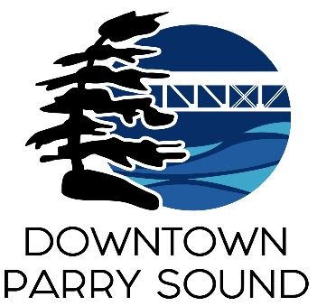
Agenda
Parry Sound Downtown Business Association
Board of Directors Meeting

April 12th, 2023 at 6pm – Parry Sound Public Library
ITEM
1. Welcome & Call to Order
2. Patty Hayes of Page By Page Consulting- Action Plan
3. Additions and approval of agenda for tonight’s meeting Doug
4. Approval of minutes from March 8th, 2023 Doug
5. Conflict of interest declaration Doug
6. Correspondence April
- Liam Heffernan’s request to join the Board
- Dave Williams request to join the Board
- Email with concerns of a Board member conduct
7. Old Business
- Attendance concerns Doug
- Scotia Bank – change of signers April
- Monthly meeting time change

8. New Business April
- Patio applications received
- 2022 audit and AGM
9. Reports:
- Financials Meredith
- Beautification Bernice
- Events Mary-Ellen
- Marketing Seanan
- Council Representative Chris
- Executive Director April

Next Meeting: May 10th, 2023 - 6pm - Parry Sound Public Library Adjournment

