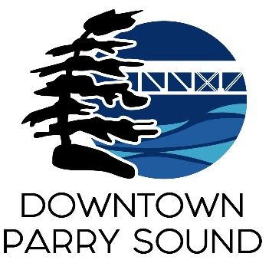
Agenda
Parry Sound Downtown Business Association
Board of Directors Meeting & 2023 AGM

May 8, 2024 at 6:30pm – Parry Sound Public Library
ITEM
1. Welcome, call to order, introductions of the Board of Directors & guests April
2. Additions and approval of agenda for tonight’s meeting. April
3. Approval of minutes: June 14, 2023 (AGM minutes) & April 10, 2024 April
4. Conflict of interest declaration for this meeting April
5. Correspondence April
6. 2023 social media review presentation Krista Holmes
7. Financial report Kail Stevenson
8. 2023 year in review & looking ahead to 2024 presentation April
9. Old Business April
- Audit update.
9. New Business April
- Q & A with Board members

Next Meeting: June 12, 2024 – 6:30pm - Parry Sound Public Library Adjournment

