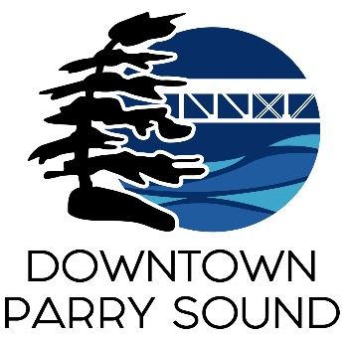
Agenda
Parry Sound Downtown Business Association
March 13, 2024, 6:30pm – Parry Sound Public Library

ITEM
1. Welcome & Call to order. Doug
2. Additions and approval of agenda for tonight’s meeting. Doug
3. Approval of minutes from February 21, 2024. Doug
4. Conflict of interest declaration. Doug
5. Correspondence: April

6. Old Business:
- Letter to Town of Parry Sound update
- AGM location
- Action Plan: Governance Committee – invite Rebecca April
7. New Business: April

8. Reports:
- Financials Kaila/April
- Beautification Bernice
- Events Dave/April
- Marketing April
- Council Representative Chris
- Executive Director April
Next Meeting: April 10, 2024 Parry Sound Public Library

