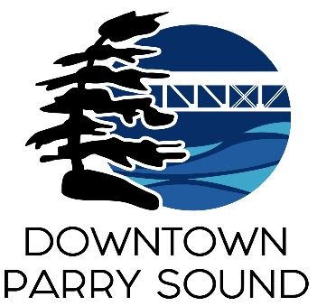
Agenda
Parry Sound Downtown Business Association
January 10, 2024, 6:30pm – Parry Sound Public Library

ITEM
1. Welcome & Call to order. Doug
2. Additions and approval of agenda for tonight’s meeting. Doug
3. Approval of minutes from November 8, 2023. Doug
4. Conflict of interest declaration. Doug
5. Correspondence: April
- Feed back re: Girlfriends Weekend.
- Vladimir Shehovtsov resignation.
- Witches Walk – thank you card.
- Parry Sound CruZers – car show
- Rebecca Johnson – Council requests letter of support for RNIP program
6. Old Business: April
- Scotia Bank
- Action Plan: insurance, priority items
7. New Business: April
- Matt Meglio – removal from Board
- 2024 meeting dates, time, location.
- 2023 Audit – AGM date
- Grants
- Information booth at Town Dock.
- April’s contract. Doug
- 2024 proposed budget. Kaila
8. Reports:
- Financials Kaila
- Beautification Bernice
- Events Dave
- Marketing Seanan
- Council Representative Chris
- Executive Director April
Next Meeting:

