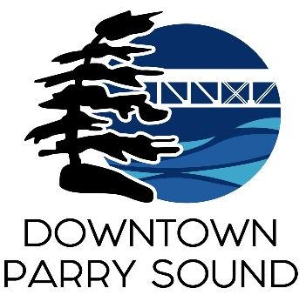
Agenda
Parry Sound Downtown Business Association
February 21, 2024, 6:30pm – Parry Sound Public Library

ITEM
1. Welcome & Call to order. Doug
2. Additions and approval of agenda for tonight’s meeting. Doug
3. Approval of minutes from January 10, 2024. Doug
4. Conflict of interest declaration. Doug
5. Correspondence: April
- Meredith McCaffrey request to rejoin the Board.
6. Old Business:
- Parry Sound CruZers meeting Don/Tim
- Action Plan: Governance Committee April
7. New Business: April
- Women’s Day event March 7, 2024
8. Reports:
- Financials Kaila/April
- Beautification Bernice
- Events Dave/April
- Marketing April
- Council Representative Chris
- Executive Director April
Next Meeting: March 13, 2024 Parry Sound Public Library

