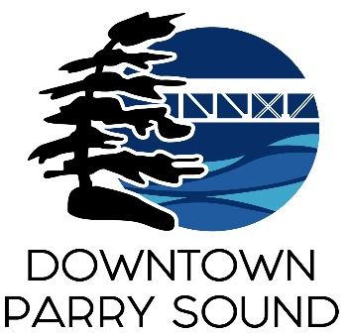
Agenda
Parry Sound Downtown Business Association
April 10, 2024, 6:30pm – Parry Sound Public Library

ITEM
1. Welcome & Call to order. Doug
2. Additions and approval of agenda for tonight’s meeting. Doug
3. Approval of minutes from March 13, 2024. Doug
4. Conflict of interest declaration. Doug
5. Correspondence: April
- Robin James re: accident at SOF Spray Car Wash 5 Great North Road
- Town of Parry Sound re: car show
- Don Corbett
6. Old Business: April
- Audit
- Action Plan
7. New Business: April
- Peter Scully presentation – Low speed, electric shuttle
- Frank Camenzuli & Sean Solowski – additional parking proposal
8. Reports:
- Financials Kaila
- Beautification Bernice
- Events April
- Marketing April
- Council Representative Chris
- Executive Director April
Next Meeting: also, AGM May 8, 2024 Parry Sound Public Library

