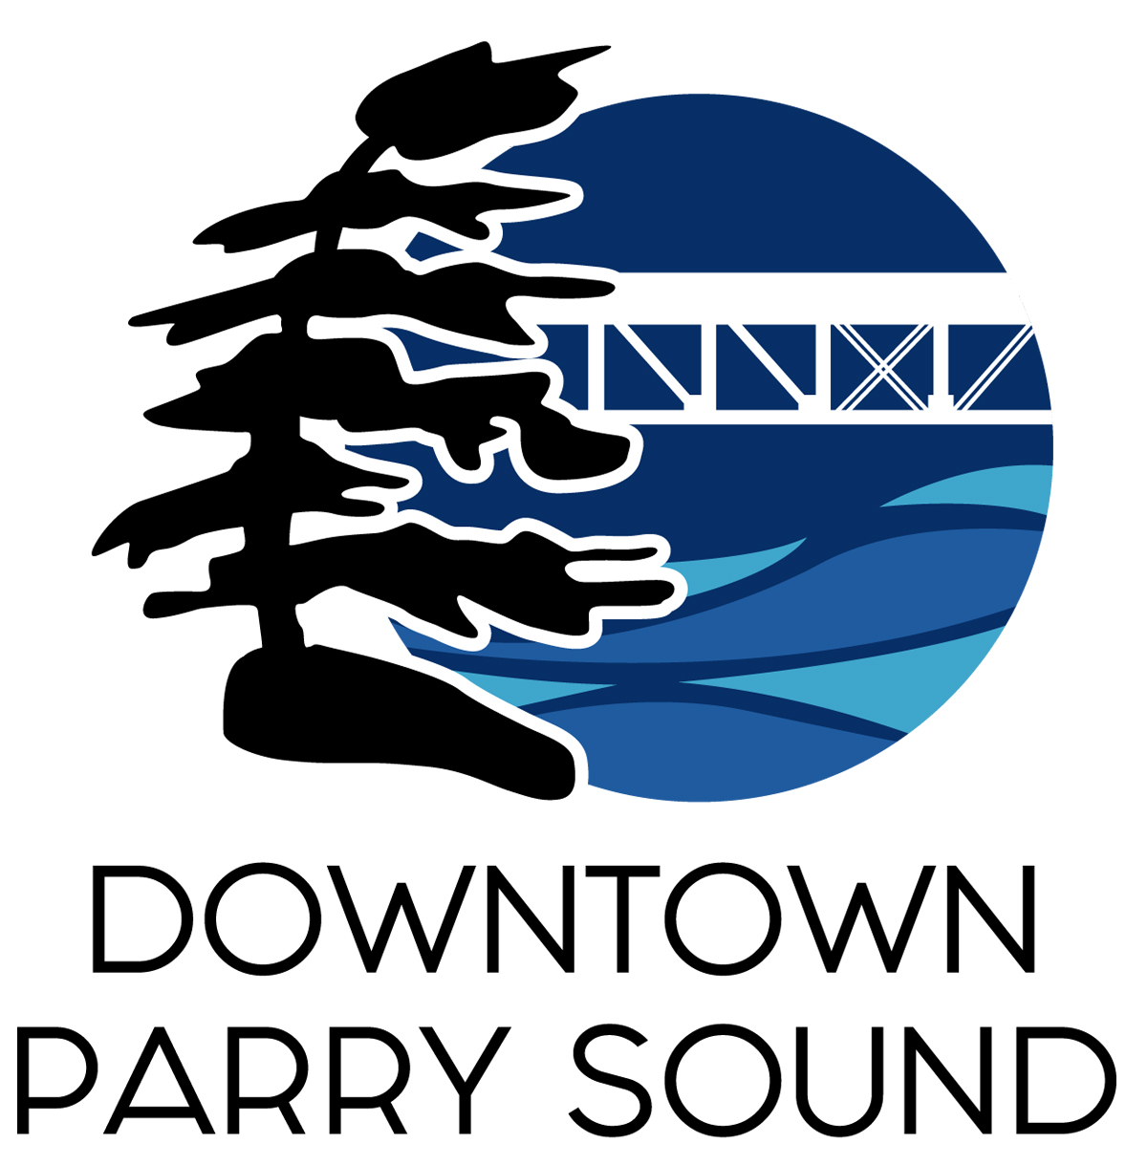

Parry Sound Downtown Business Association
Annual General Meeting
Draft Agenda
December 14th 6:30pm
Parry Sound Public Library

- Call to Order and Welcome
- Approval and additions of December 14th, 2022 AGM Agenda
- Approval of AGM Minutes from October 6th, 2021
- Approval of Minutes from November 9th, 2022
- Review of Financial Statements for year ending December 31, 2021
- Council Representative Roger Burden – year end wrap up
- Introduction of new Board
- 2023 Budget
- Plans for 2023 with presentations by:
- Amy Black – Chair of our Events Committee
- Krista Holmes – Social Media Manager
- Seanan Megyesi – Chair of our Marketing Committee
- Brenda Ryan – Chair of our Beautification Committee
- Any additional Business, Question & Answer Period
- Closing and thank you
- Adjournment

